Office Use Only: DSM

__________________________________
AXIS I:

__________________________________AXIS II:

__________________________________
AXIS III:

__________________________________AXIS IV:

__________________________________AXIS V GAF:

ADULT CLIENT INFORMATION (CONFIDENTIAL)

Name ______________________________________________________________________

Age __________ DOB: / / SS#: ______________________________________________________

Address________________________________________________ City_____________________State______ ZIP__________
Home phone ____________________________________________ Cell ______________________________________

Employer________________________________________________ Email ____________________________________

Spouse’s name______________________________________________________ DOB: / /

Spouse’s Employer______________________________________ Work phone ____________________Cell________________

May we contact you via email? Yes______ No______ Call you at home? Yes _____ No_____
Other Phone Number: _____________________________________ Name:___________________________ __________________________________________________________________________________________________________
RESPONSIBLE PARTY

Name of person responsible for this account if different from above__________________________________________________

Address_____________________________________________________Home phone_________________ Work phone_______________

Birthdate____________________Soc Sec#___________________________ Employer___________________________________

INSURANCE INFORMATION

Inurance Co__________________________________________________Mental Health phone#____________________________

Policy ID#___________________________________________________Group#_________________________________________

DO YOU HAVE ADDITIONAL INSURANCE? YES_______NO_____ (IF YES COMPLETE THE FOLLOWING)

Name of insured______________________________________________________Relationship to client____________________

Birthdate___________________________________________Soc Sec#_______________________________________________

Insurance co___________________________________Policy ID#____________________________Group_________________

I hereby authorize the release of any medical and/or other information necessary to process claims to my insurance company. I also hereby authorize payment of medical benefits from my insurance company to the above named therapist for services provided.

****SIGNATURE OF RESPONSIBLE PARTY DATE

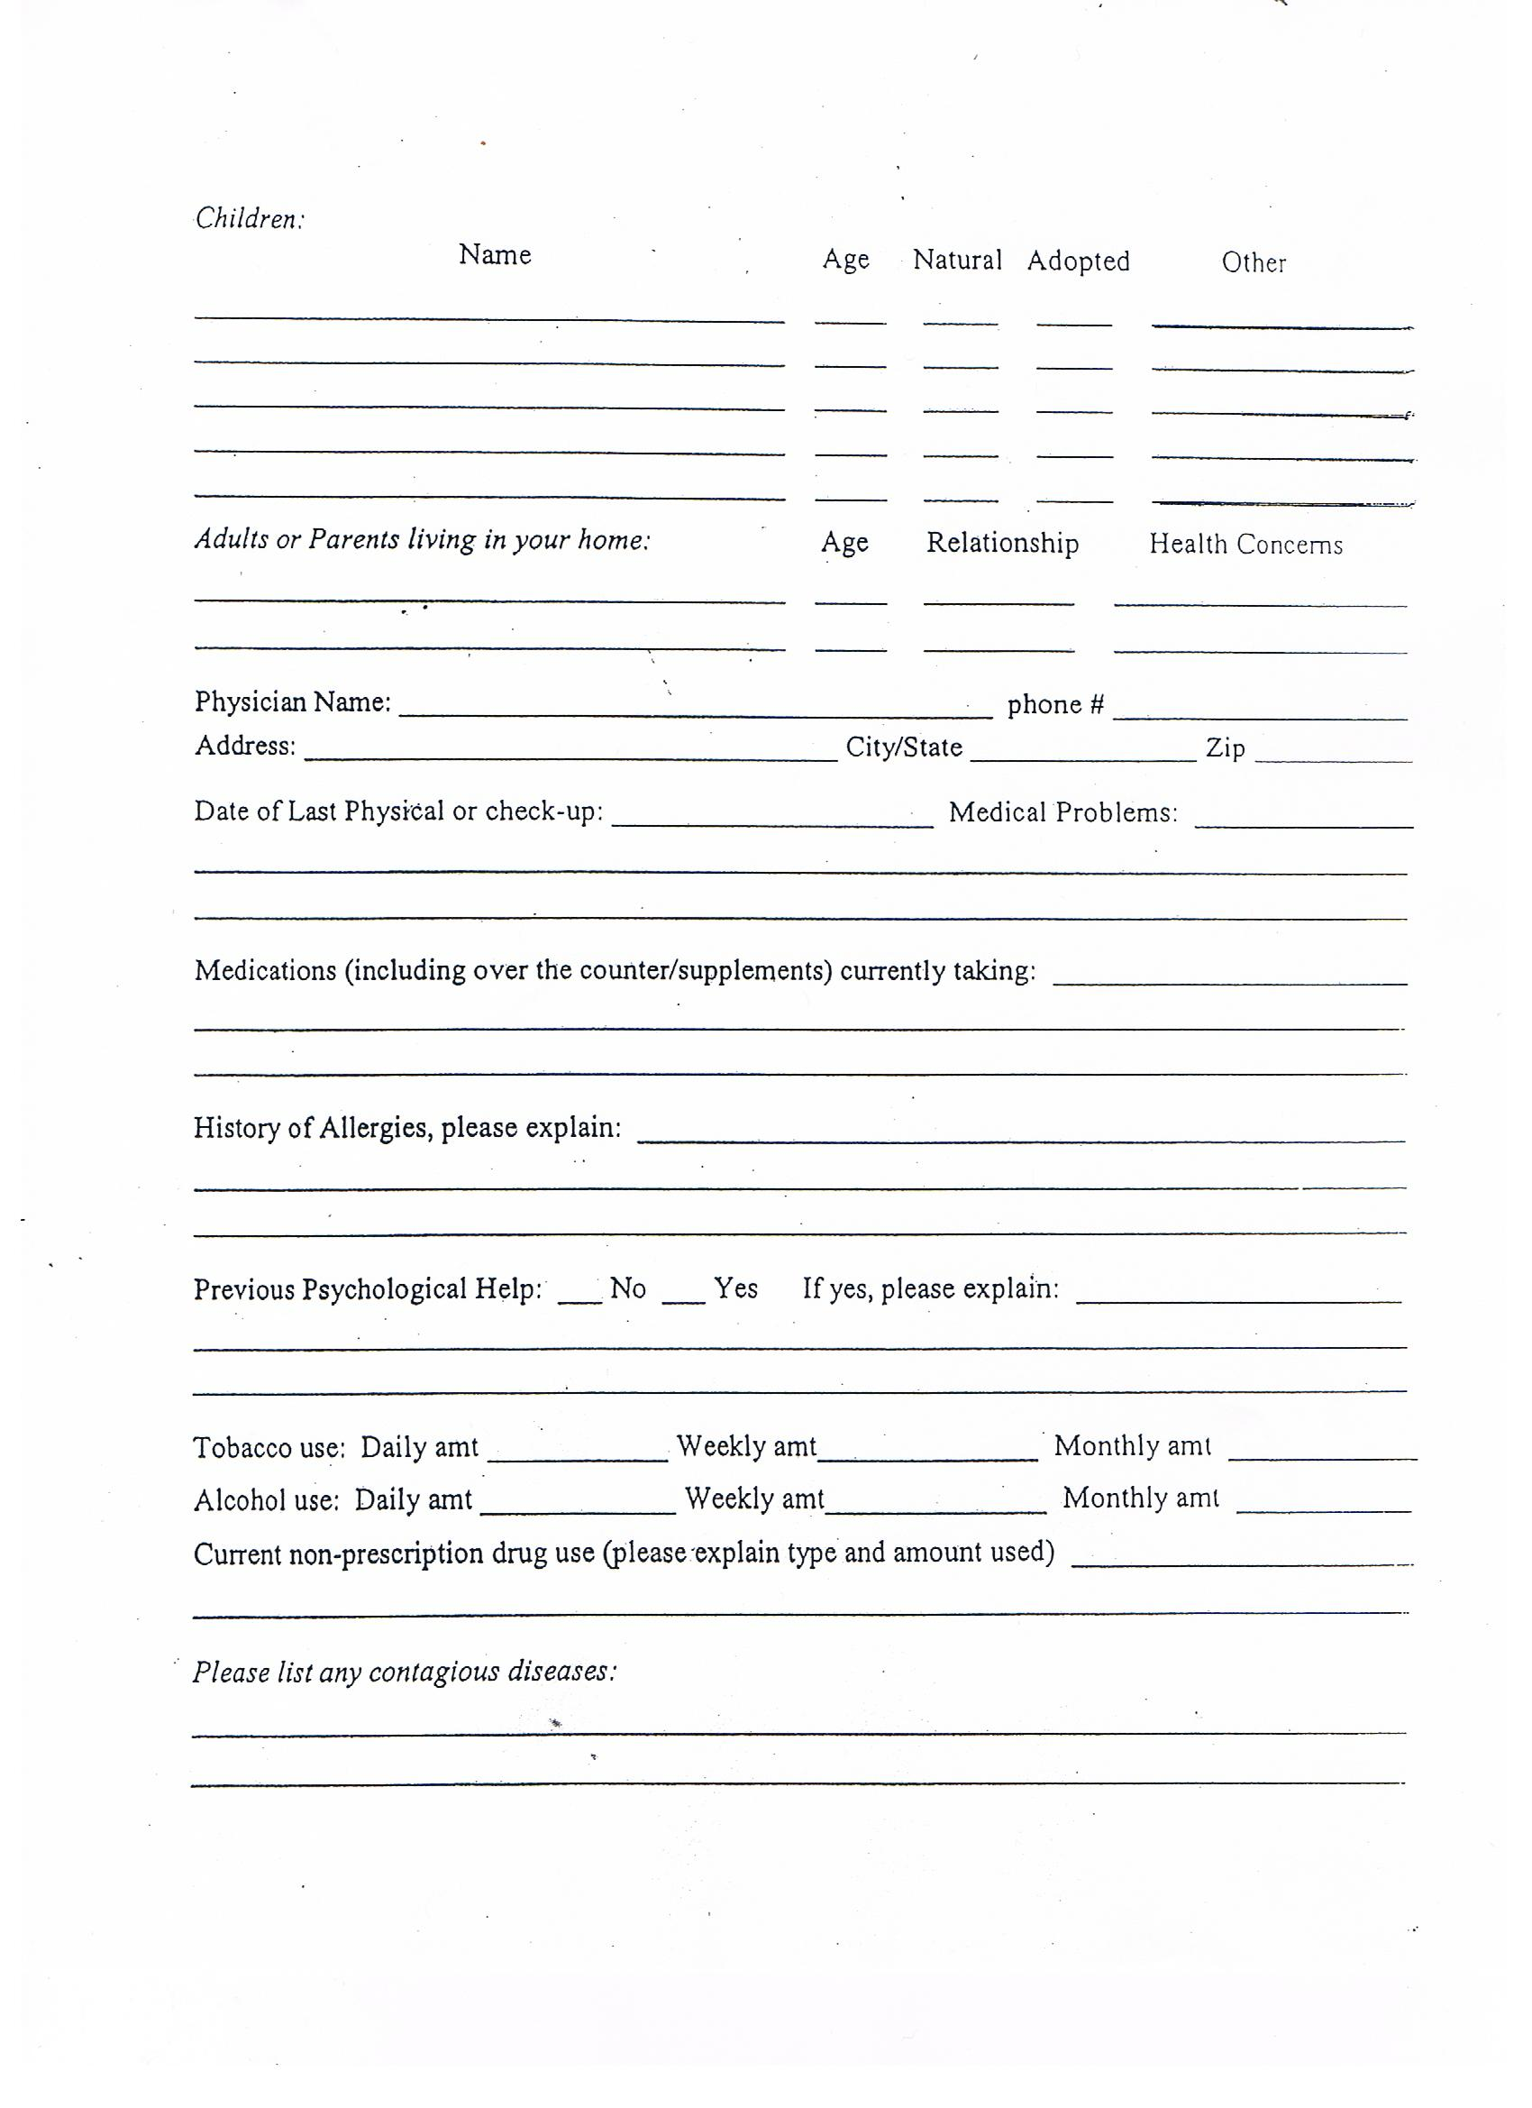
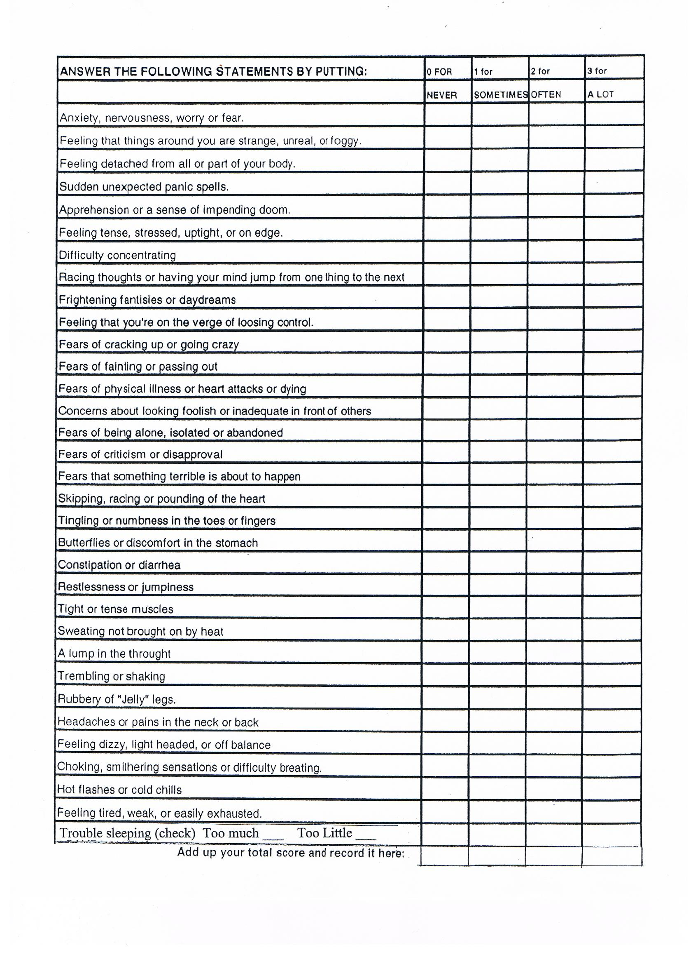
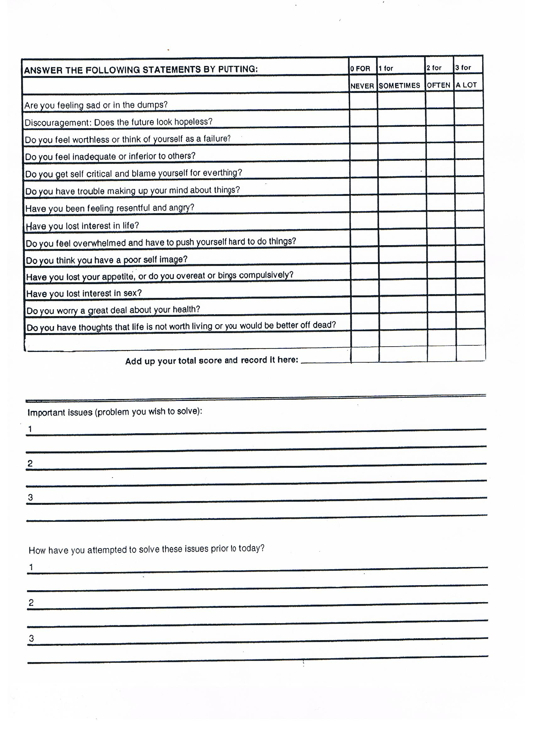

CENTERS FOR BEHAVIORAL HEALTH ~ INFORMATION AND POLICIES
Page 1 of 2
THERAPISTS:
Carla Enyart M.S., L.P.C.
CONFIDENTIALITY:
The privacy of your therapy and counseling is considered to be of the utmost importance to your therapist and staff. There are times however, when information must be shared with others. These times are:

- Insurance: A medical or psychiatric diagnosis is required in order to justify payment.
- Managed Care: All HMO’s, POS, and some PPO’s and EAP’s require a detailed treatment plan before authorizing additional sessions beyond the original authorization. A typical Treatment Plan contains:
  - A statement of the problem for which you sought treatment
  - Your psychiatric diagnosis
  - Your symptoms to justify the psychiatric diagnosis
  - Your alcohol or drug use
  - Your history of previous mental health treatment
  - Your current medications and/or medical concerns
  - Your treatment goals
  - The methods your therapist will use to help you achieve your goals
  - Your progress made towards those goals

Your managed care plan/provider usually requires us to keep your primary care physician informed of your treatment.

FEES AND PAYMENT:
A full session is 45 minutes unless other arrangements have been made. The fee for the First session is $125.00. Follow-up sessions are $110.00. We will bill your insurance company for you as a courtesy. However, you are ultimately responsible for the payment if not paid by the insurance provider. Payments and co-payments must be made at the time of service. We accept major credit cards, checks or cash of exact amounts. Upon request, we will provide you with a receipt that you may use for insurance reimbursement if necessary. In the case of minor children, the parent bringing the child in for treatment will be held responsible for payment at the time of service. THERE ARE NO EXCEPTIONS TO THIS POLICY. You will be charged an interest fee at the rate of 15% on balances over 60 days old. If an account is turned over for collection, you agree to pay court costs and reasonable attorney’s fees and/or collection fees. If you are a member of a managed care program, co-payment and/or deductible amounts must be paid at the time of service. If your program requires pre-authorization, you need to supply the necessary information to us prior to your visit. You are responsible for providing us with any insurance updates or changes prior to services being rendered. If for some reason a co-pay is not paid at time of service, a $2.00 postage/handling fee will be added to your co-pay amount for each co-pay owed.

TELEPHONE CONTACT:
Making or changing appointments, discussing bills, etc., can be handled by speaking to the receptionist. If you leave a voice mail, your call will be returned as soon as possible. Therapy on the telephone, internet, or cell phone will be charged our standard fee of $110.00 for 45 minutes, or a minimum of $27.50 for each clinical communication of 15 minutes or less. There is no charge for calls that are administrative in nature.

Page 2 of 2
PREPARATION OF WRITTEN DOCUMENTS
Preparation of reports, clinical summaries, and letters requested by you or for your behalf will require a fee based on the time spent in its preparation. The minimum fee is $27.50 for reports based on preparation time of 15 minutes or less.

COURT APPEARANCES, OTHER APPEARANCES, AND TRAVEL TIME
Court appearances, other appearances, and travel time will be billed at our customary hourly rate of $110.00 unless other arrangements have been made.

CANCELLED AND MISSED APPOINTMENTS-CANCELLATION POLICY
An appointment is reserved for you. If you must cancel that appointment, you must call the office at least 24 hours in advance to avoid a Missed Appointment Fee. A late cancellation (less than 24 hours before your appointment will result in a charge of $27.50 to cover part of our costs of holding open that time for you. Should you not call at all to cancel and fail to keep your appointment, the fee is $55.00 for the first incident. Future missed appointments will be charged our standard fee of $110.00 unless other arrangements have been made.

24 hours or more in advance notice of cancellation = No Fee
Call to cancel in less than 24 hours = $27.50
Do not call, and not keep your appointment = $55.00
Second incident and thereafter of failure to keep appointment(s) = $110.00

TERMINATION OF THERAPY
If you have not had a termination session with your therapist, your case is considered closed in thirty days after the last contact.

I have read and understand the above information and agree to theses policies. I understand that I am responsible for all charges regardless of insurance coverage. I agree to receive psychological services and I authorize the release of information to my managed care company and/or my insurance company necessary for reimbursement.

____________________________________________________ _____________________
Client Signature (Guardian if minor) Date

____________________________________________________
Client Name

________________________________________________________________________________________

EMERGENCIES
If you need immediate help and cannot reach your therapist at Centers for Behavioral Health, please call
(BHR) Behavioral Health Response (314) 469-6644 or 1-800-811-4760. We are not affiliated with BHR,
a state run crisis hotline. If it is life-threatening emergency, go to the nearest hospital emergency room.
_________________________________________________________________________________________
